Circular Primes
# Source: AI Source: Provided by: [Data Path: Persons Table -> ID Column: 1, Name_En Column: Motasem Essam] -> From: [ChatGPT] on [7/13/2026]
A circular prime is a prime number that remains prime under every cyclic rotation of its decimal digits.
A cyclic rotation moves the first digit to the end (or equivalently rotates the digits in a circle).
For example,
$$197$$
has the rotations
$$197, 971, 719.$$
Since all three numbers are prime, 197 is a circular prime.
Circular primes are studied in number theory, digit patterns, and computational mathematics.

Definition
# Source: AI Source: Provided by: [Data Path: Persons Table -> ID Column: 1, Name_En Column: Motasem Essam] -> From: [ChatGPT] on [7/13/2026]
A circular prime is a prime number such that every cyclic rotation of its decimal digits is also prime.
If any rotation is composite, the number is not a circular prime.

Rules for Circular Primes

1. The Original Number Must Be Prime
# Source: AI Source: Provided by: [Data Path: Persons Table -> ID Column: 1, Name_En Column: Motasem Essam] -> From: [ChatGPT] on [7/13/2026]
The original number must be prime.
Example
$$197$$
is prime.

2. Generate Every Cyclic Rotation
# Source: AI Source: Provided by: [Data Path: Persons Table -> ID Column: 1, Name_En Column: Motasem Essam] -> From: [ChatGPT] on [7/13/2026]
Rotate the digits one position at a time.
Example
For
$$197,$$
the rotations are
$$197, \\ 971, \\ 719.$$

3. Every Rotation Must Be Prime
# Source: AI Source: Provided by: [Data Path: Persons Table -> ID Column: 1, Name_En Column: Motasem Essam] -> From: [ChatGPT] on [7/13/2026]
Each rotated number must be prime.
Example
$$197, 971, 719$$
are all prime.
Therefore,
197 is a circular prime.

4. If Any Rotation Is Composite, the Number Is Not a Circular Prime
# Source: AI Source: Provided by: [Data Path: Persons Table -> ID Column: 1, Name_En Column: Motasem Essam] -> From: [ChatGPT] on [7/13/2026]
Example
Consider
$$23.$$
Its rotations are
$$23, 32.$$
Since
$$32$$
is composite,
23 is not a circular prime.

5. Multi-Digit Circular Primes Cannot Contain Certain Digits
# Source: AI Source: Provided by: [Data Path: Persons Table -> ID Column: 1, Name_En Column: Motasem Essam] -> From: [ChatGPT] on [7/13/2026]
Except for the one-digit primes
$$2$$
and
$$5,$$
a multi-digit circular prime cannot contain
$$0, 2, 4, 5, 6, 8.$$
Otherwise, one of its rotations would end with an even digit or 5, making it composite.
Example
$$127$$
contains the digit
$$2.$$
One rotation is
$$712,$$
which is even.
Therefore,
127 cannot be a circular prime.

6. Circular Primes Become Increasingly Rare
# Source: AI Source: Provided by: [Data Path: Persons Table -> ID Column: 1, Name_En Column: Motasem Essam] -> From: [ChatGPT] on [7/13/2026]
As numbers become larger,
it becomes increasingly difficult for every rotation to remain prime.

7. It Is Unknown Whether Infinitely Many Circular Primes Exist
# Source: AI Source: Provided by: [Data Path: Persons Table -> ID Column: 1, Name_En Column: Motasem Essam] -> From: [ChatGPT] on [7/13/2026]
Mathematicians do not know whether infinitely many circular primes exist.
This remains an open problem.

First Circular Primes
# Source: AI Source: Provided by: [Data Path: Persons Table -> ID Column: 1, Name_En Column: Motasem Essam] -> From: [ChatGPT] on [7/13/2026]
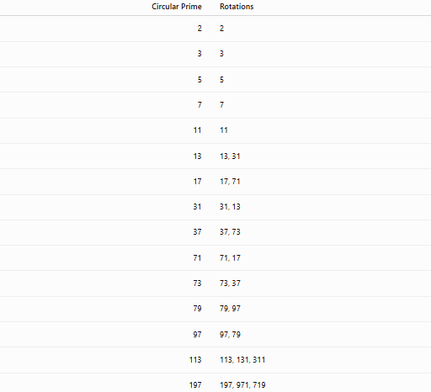
Circular Prime | Rotations
2 | 2
3 | 3
5 | 5
7 | 7
11 | 11
13 | 13, 31
17 | 17, 71
31 | 31, 13
37 | 37, 73
71 | 71, 17
73 | 73, 37
79 | 79, 97
97 | 97, 79
113 | 113, 131, 311
197 | 197, 971, 719

Examples
# Source: AI Source: Provided by: [Data Path: Persons Table -> ID Column: 1, Name_En Column: Motasem Essam] -> From: [ChatGPT] on [7/13/2026]
Example 1
Determine whether
$$13$$
is a circular prime.
Rotations:
$$13, 31.$$
Both are prime.
Therefore,
13 is a circular prime.

Example 2
Determine whether
$$17$$
is a circular prime.
Rotations:
$$17, 71.$$
Both are prime.
Therefore,
17 is a circular prime.

Example 3
Determine whether
$$197$$
is a circular prime.
Rotations:
$$197, \\ 971, \\ 719.$$
All are prime.
Therefore,
197 is a circular prime.

Example 4
Determine whether
$$23$$
is a circular prime.
Rotations:
$$23, 32.$$
Since
$$32$$
is composite,
23 is not a circular prime.

Example 5
Determine whether
$$1193$$
is a circular prime.
Rotations:
$$1193, \\ 1931, \\ 9311, \\ 3119.$$
All four numbers are prime.
Therefore,
1193 is a circular prime.

Example 6
Determine whether
$$101$$
is a circular prime.
Rotations:
$$101, \\ 011=11, \\ 110.$$
Since
$$110$$
is composite,
101 is not a circular prime.

Common Circular Primes
# Source: AI Source: Provided by: [Data Path: Persons Table -> ID Column: 1, Name_En Column: Motasem Essam] -> From: [ChatGPT] on [7/13/2026]
Some well-known circular primes are
$$2, \\ 3, \\ 5, \\ 7, \\ 11, \\ 13, \\ 17, \\ 31, \\ 37, \\ 71, \\ 73, \\ 79, \\ 97, \\ 113, \\ 131, \\ 197, \\ 199, \\ 311, \\ 337, \\ 1193.$$

How to Determine Whether a Number Is a Circular Prime
# Source: AI Source: Provided by: [Data Path: Persons Table -> ID Column: 1, Name_En Column: Motasem Essam] -> From: [ChatGPT] on [7/13/2026]
- Verify that the original number is prime.
- Generate every cyclic rotation of its digits.
- Test each rotation for primality.
- If every rotation is prime, the number is a circular prime.
Example
Check
$$197.$$
Rotations:
$$197, 971, 719.$$
All are prime.
Therefore,
197 is a circular prime.

Real-Life Applications
# Source: AI Source: Provided by: [Data Path: Persons Table -> ID Column: 1, Name_En Column: Motasem Essam] -> From: [ChatGPT] on [7/13/2026]
Circular primes are primarily used in:
- Number theory research
- Computational mathematics
- Prime number searches
- Primality testing
- Algorithm development
- Mathematical software
- Computer science
- Mathematics education
- Recreational mathematics
- Research in digit-based number patterns

Real-Life Examples
# Source: AI Source: Provided by: [Data Path: Persons Table -> ID Column: 1, Name_En Column: Motasem Essam] -> From: [ChatGPT] on [7/13/2026]
1. Number Theory Research
Researchers investigate circular primes to study how digit rotations interact with primality.

2. Computational Mathematics
Algorithms efficiently generate all cyclic rotations and test each for primality.

3. Prime Number Searches
Large prime databases are searched for circular prime families.

4. Mathematical Software
Computer algebra systems identify circular primes by generating rotations automatically.

5. Recreational Mathematics
Circular primes are a popular example of numbers exhibiting both symmetry and prime-number properties.

6. Mathematics Education
They demonstrate how digit manipulation, cyclic permutations, and prime testing can be combined.

Common Mistakes
# Source: AI Source: Provided by: [Data Path: Persons Table -> ID Column: 1, Name_En Column: Motasem Essam] -> From: [ChatGPT] on [7/13/2026]
- Confusing circular primes with emirp primes.
- Checking only one rotation instead of all rotations.
- Forgetting that every rotation must be prime.
- Ignoring rotations that begin with zero (for example, $101→011$).
- Assuming every reversible prime is also a circular prime.

Key Points
# Source: AI Source: Provided by: [Data Path: Persons Table -> ID Column: 1, Name_En Column: Motasem Essam] -> From: [ChatGPT] on [7/13/2026]
- A circular prime remains prime after every cyclic rotation of its digits.
- Every rotation must be prime.
- Multi-digit circular primes cannot contain the digits
$$0, 2, 4, 5, 6, 8.$$
- Every circular prime is prime, but not every prime is circular.
- Circular primes are studied in number theory and computational mathematics.
- Whether infinitely many circular primes exist remains an open problem.

Circular Primes vs. Emirp Primes
# Source: AI Source: Provided by: [Data Path: Persons Table -> ID Column: 1, Name_En Column: Motasem Essam] -> From: [ChatGPT] on [7/13/2026]
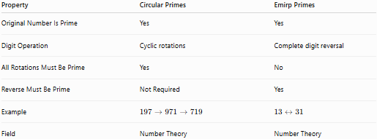
Property | Circular Primes | Emirp Primes
Original Number Is Prime | Yes | Yes
Digit Operation | Cyclic rotations | Complete digit reversal
All Rotations Must Be Prime | Yes | No
Reverse Must Be Prime | Not Required | Yes
Example | $$197→971→719$$ | $$13↔31$$
Field | Number Theory | Number Theory

Circular Primes vs. Palindromic Primes
# Source: AI Source: Provided by: [Data Path: Persons Table -> ID Column: 1, Name_En Column: Motasem Essam] -> From: [ChatGPT] on [7/13/2026]
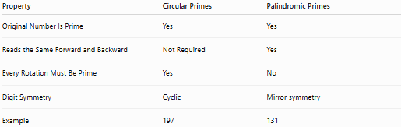
Property | Circular Primes | Palindromic Primes
Original Number Is Prime | Yes | Yes
Reads the Same Forward and Backward | Not Required | Yes
Every Rotation Must Be Prime | Yes | No
Digit Symmetry | Cyclic | Mirror symmetry
Example | 197 | 131

Conclusion
# Source: AI Source: Provided by: [Data Path: Persons Table -> ID Column: 1, Name_En Column: Motasem Essam] -> From: [ChatGPT] on [7/13/2026]
A circular prime is a prime number that remains prime under every cyclic rotation of its decimal digits. Unlike emirp primes, which require only the reversed number to be prime, a circular prime must remain prime after all possible rotations. For example,
$$197$$
is a circular prime because
$$197, 971, 719$$
are all prime. Circular primes form one of the most interesting families of digit-based prime numbers and are studied in number theory, computational mathematics, and recreational mathematics. Whether infinitely many circular primes exist remains an open problem.

